**P2 - Sustainable Supply Chain Performance Dashboard using Power Bi**

**TALAKANTI SAINATH REDDY  
WEEK – 1**

**sustainable supply chain performance :-**

**Getting Started with Power BI**

1. **Install Power BI Desktop**:
   * Download Power BI Desktop from the official [Power BI website](https://powerbi.microsoft.com) and install it.
2. **Open Power BI Desktop**:
   * Once installed, open the application. You'll see the interface like the one in your screenshot with options to start with a blank report or connect to data sources.

In Power BI, monitoring and analyzing **sustainable supply chain performance** involves visualizing key metrics and using the data to assess how well the supply chain adheres to sustainability goals. Sustainable supply chain performance can be evaluated through multiple dimensions like carbon footprint, waste reduction, ethical sourcing, energy consumption, supplier performance, and more.

Here’s how to structure a process to track **sustainable supply chain performance** using Power BI.

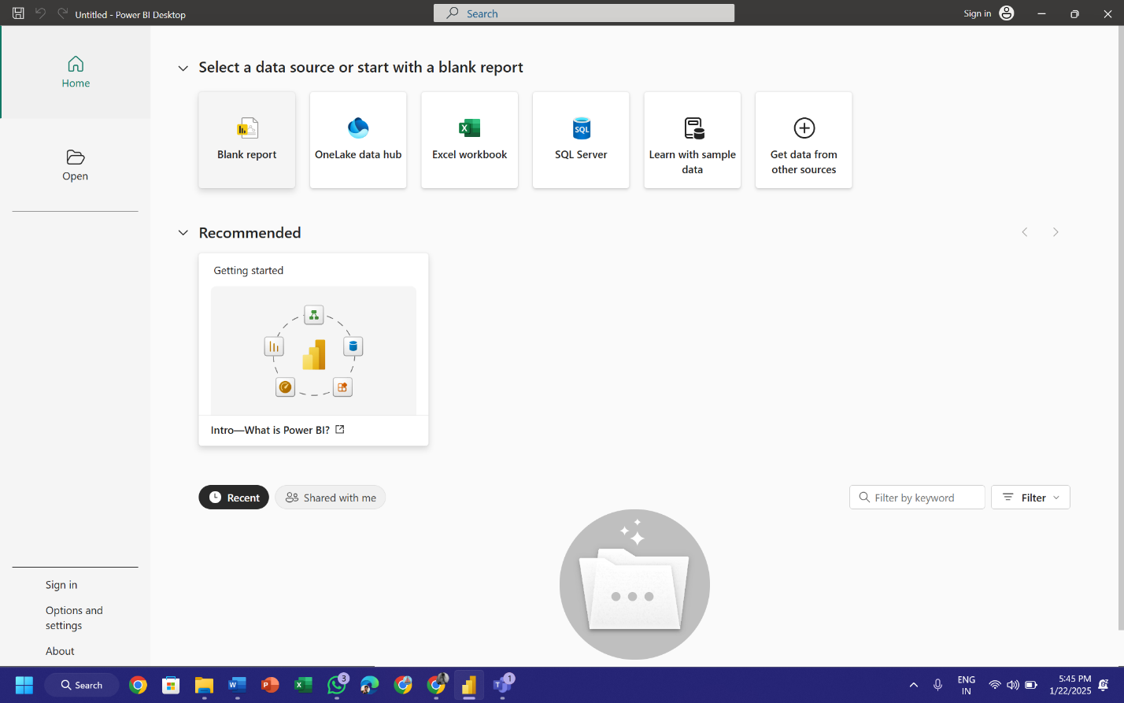

**Steps to Start with Excel Data (e.g., Sustainable Supply Chain Data):-**

1. **Open Power BI Desktop**:
   * Once installed, open the application. You'll see the interface like the one in your screenshot with options to start with a blank report or connect to data sources.

Power BI is a business intelligence tool developed by Microsoft that allows you to connect to data sources, transform data, and create insightful visualizations. Here's an overview of how to get started with Power BI and create visualizations using Excel data, like sustainable supply chain data.

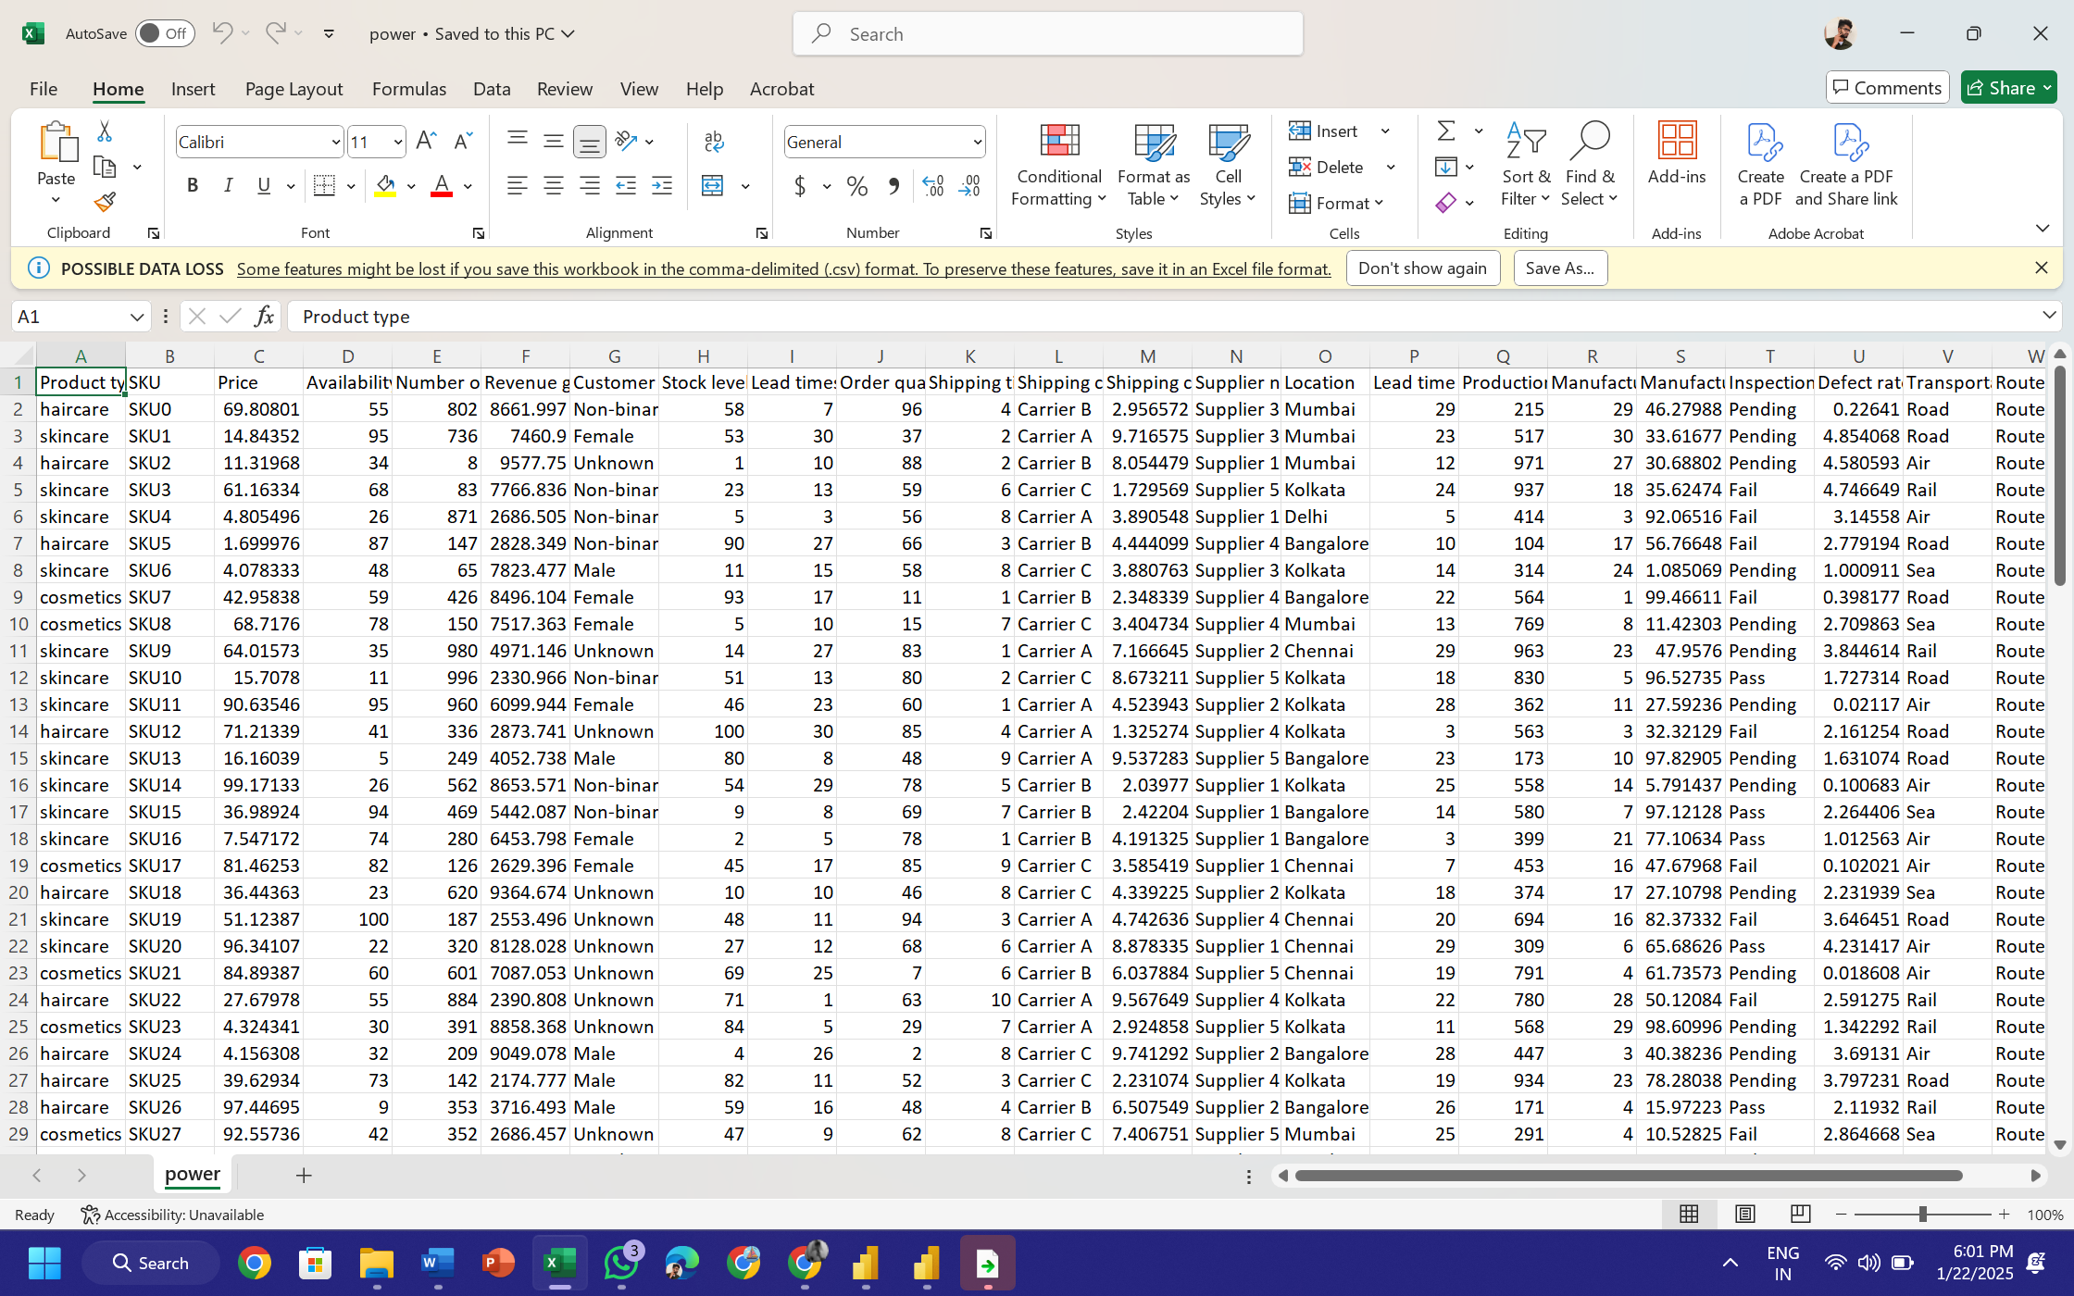

**Customize the Visualization**:

* Use the "Format" section in the Visualizations pane to customize colors, labels, and tooltips.

• Drag fields into the **Filters** pane to filter your data for specific criteria (e.g., "Year = 2024").

• Add slicers to your report for inte ractive filtering (e.g., filtering by supplier or material type)

* Visualizing **sustainable supply chain data** in both **Excel** and **Power BI** involves leveraging the tools and features each platform provides. Here's a step-by-step guide for both tools:

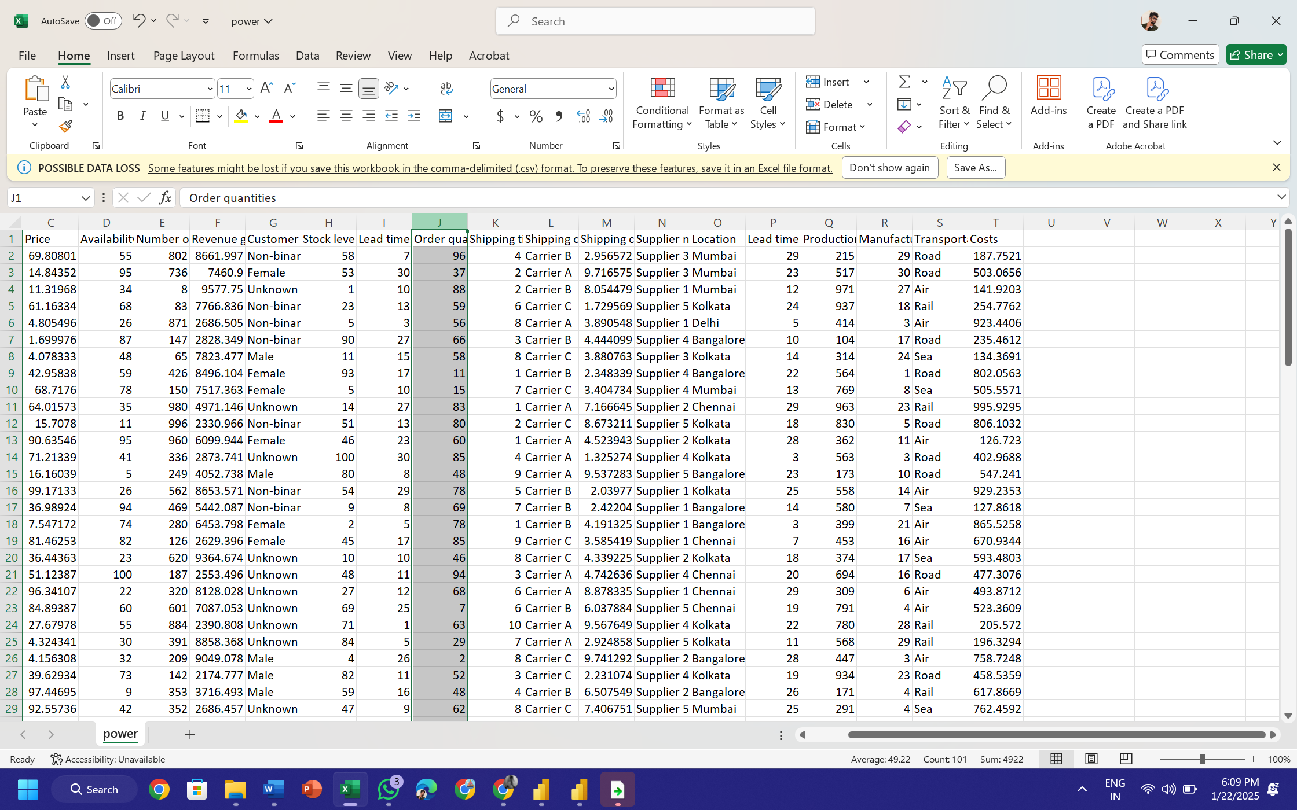

* **Step 1: Prepare Your Data**
* Before visualizing, ensure your sustainable supply chain data is clean and structured. Here's an example layout:

| * **Region** | * **Year** | * **CO2 Emissions (tons)** | * **Supplier** | * **Material Used** | * **Cost ($)** |
| --- | --- | --- | --- | --- | --- |
| * North America | * 2022 | * 150 | * Supplier A | * Recycled Plastic | * 20000 |
| * Europe | * 2023 | * 220 | * Supplier B | * Steel | * 30000 |
| * Asia | * 2022 | * 180 | * Supplier C | * Aluminum | * 25000 |

Use **Transform Data** to clean or modify your data if needed.

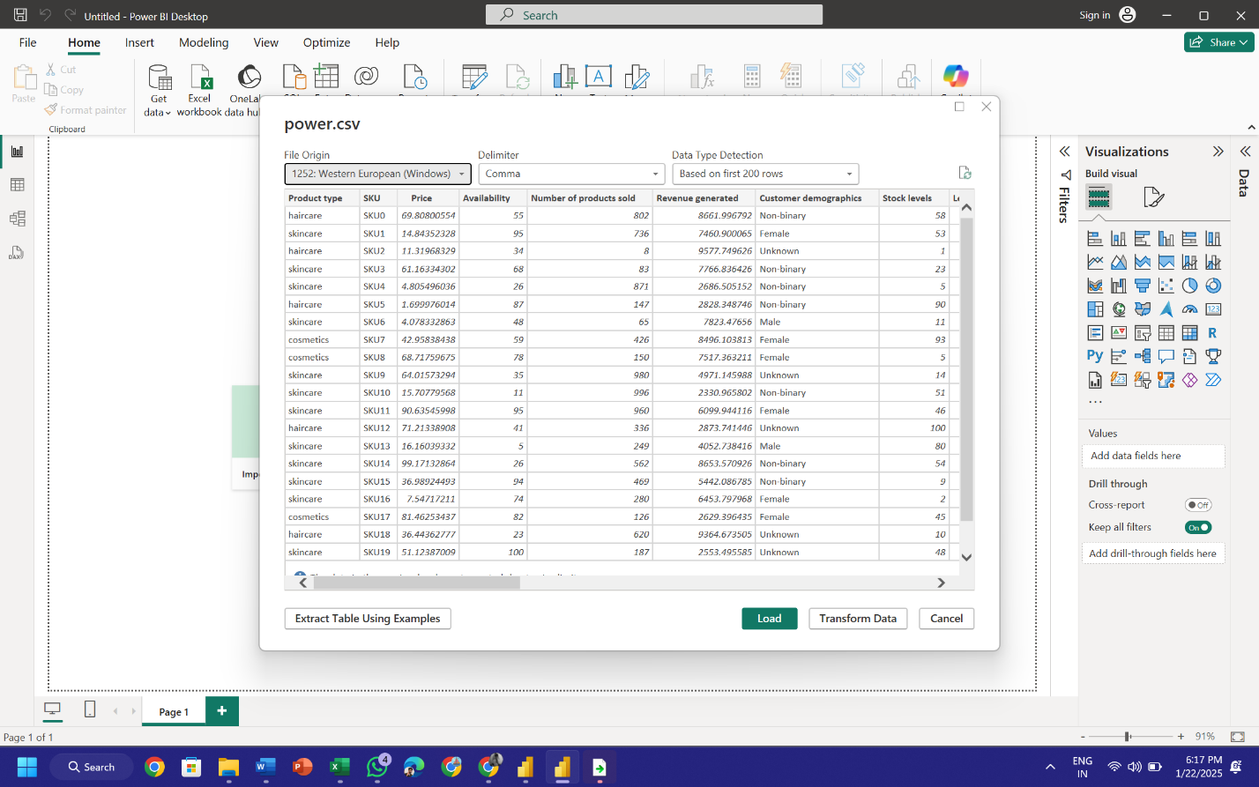

* After creating your report, go to **File > Publish > Publish to Power BI Service**.
* Share the report via Power BI online.